GUIDE TO ONLINE BOOKS AT HOME WITH MYON
- Log into MySchool with your C2k username and password
- On the Home page type this website into the BROWSER
- readon.myon.co.uk
- Click Start Reading
- Choose from the library
- Click Read
1.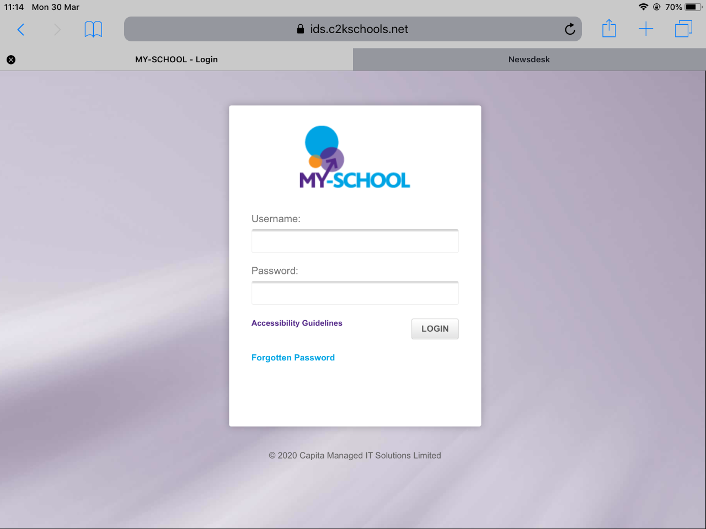 2. 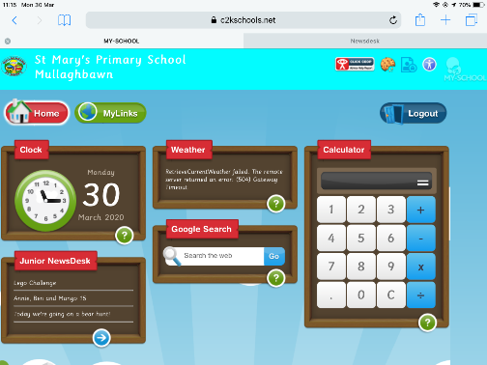

3. 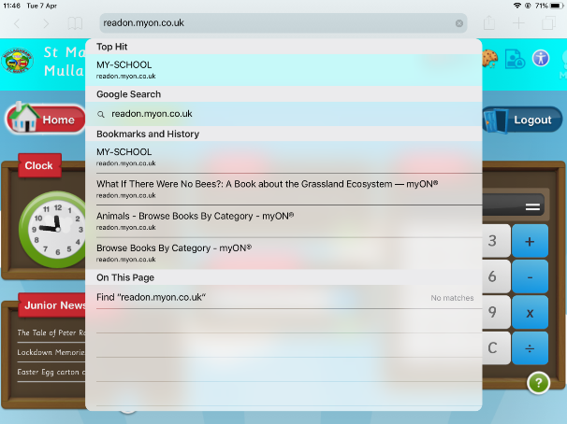 4 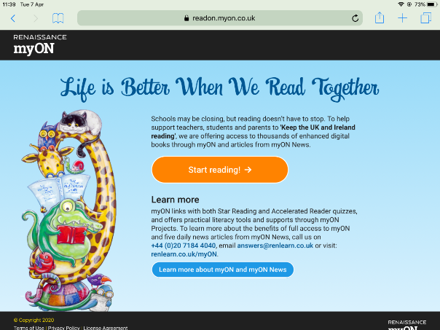

5.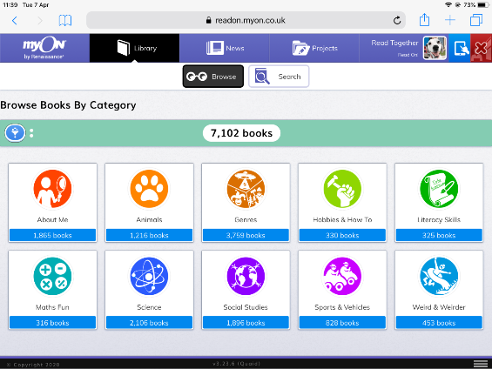 6. 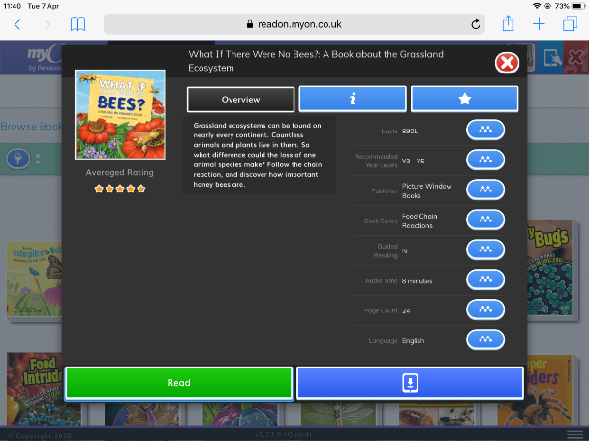
Enjoy the special attachments that these online books have incorporated, including audio readings and a dictionary
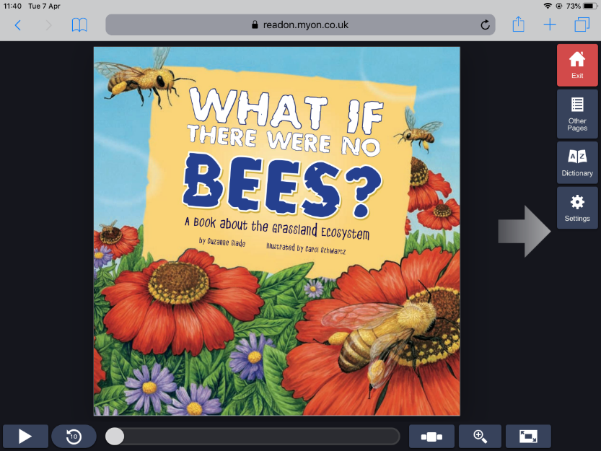

If you are an Accelerated pupil, you can check if your book has an AR quiz by typing its name into the Accelerated Reader Bookfinder at arbookfind.co.uk.

