

Aimee Walsh
For a big improvement all round in work this week.
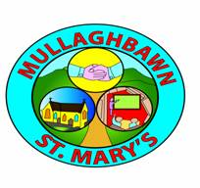
Signed

Date Friday 7th February 2014

