GUIDE TO ACCELERATED READER AT HOME

- Log into MySchool with your C2k username and password
- On the Home page type this website and school code into the BROWSER
https://ukhosted54.renlearn.co.uk/2235294
- Choose I am a student
You are now on the Accelerated Reader Log In page
- Log in with the AR Username and Password printed on the HOME CONNECT page that the school sent home. If this has been misplaced, please contact your child’s teacher for a reminder.
- You are now on the Accelerated Reader Dashboard.

- 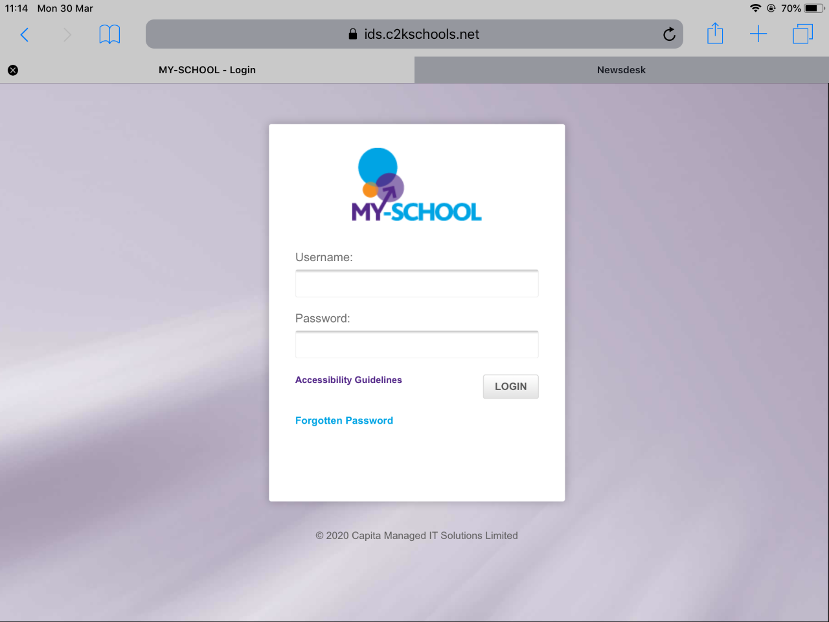 2. 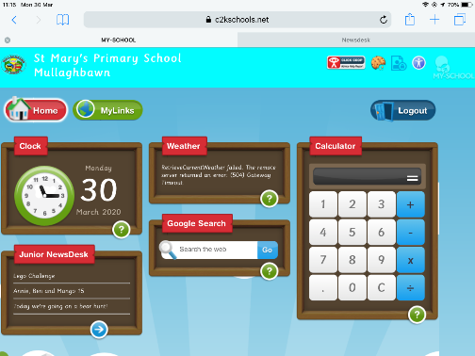
3. 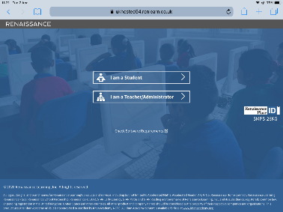 4. 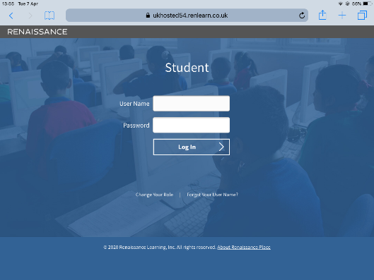
5. 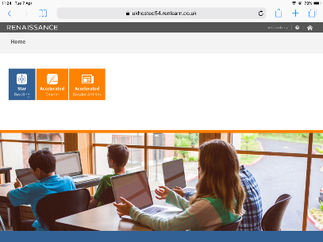
Accelerated Reader is for taking online quizzes on books that have already been read and charting progress with points, awards and certificates.
Ideally, these books should be levelled within the range of the readers ZPD so they are not too difficult or too easy. If you want to know your child’s ZPD, contact your child’s teacher.
- Click on the orange Accelerated Reader button to choose a quiz.
- Type in a book title or author to find the book you have read. If nothing appears, it is not an AR book.
- Take the quiz
- See your results. Check your TOPS report and look in My School Year Summary

6.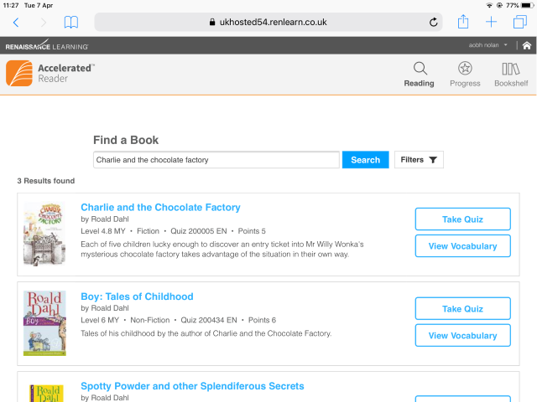 7. 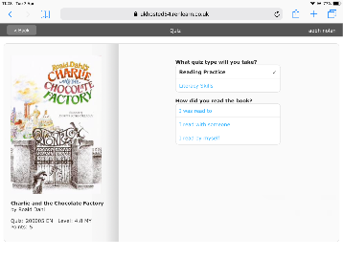

8.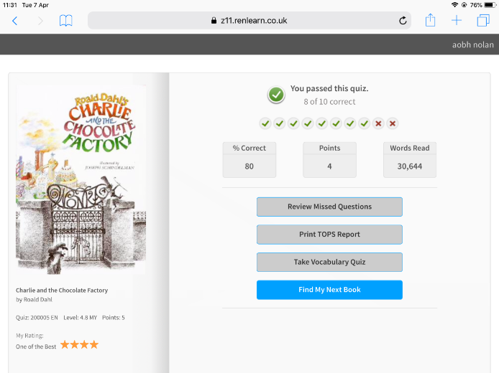 9. 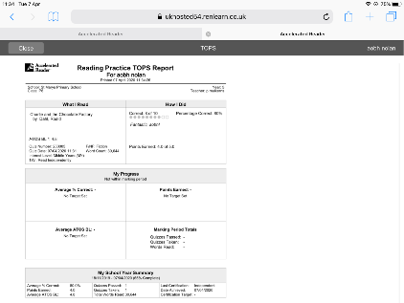

There are no books on Accelerated Reader, but there are some non-fiction articles which also have quizzes.
If you want to read these just click on the orange Accelerated Reader Articles button.

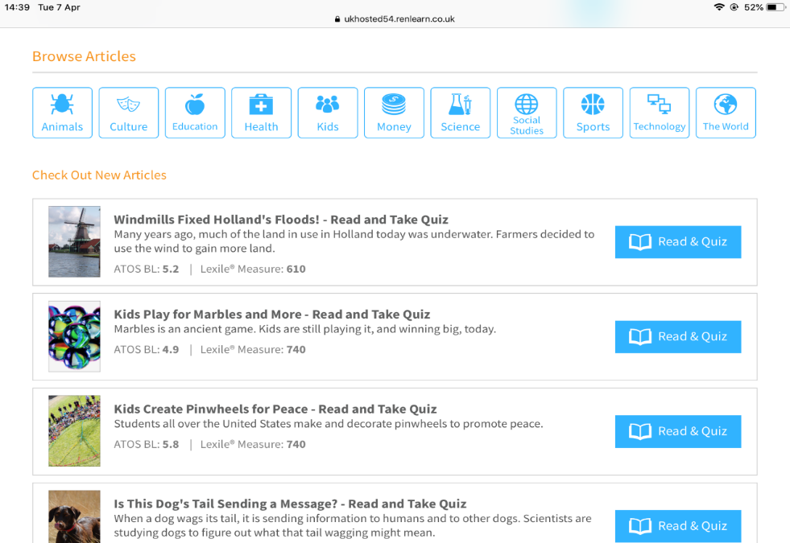

If you want online books type readon.myon.co.uk into the MySchool Homepage BROWSER

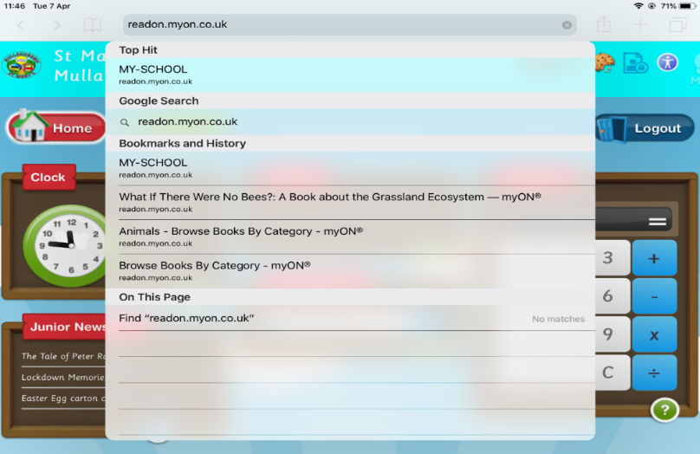
For more information visit
http://www.renlearn.co.uk/renaissance-at-home/

