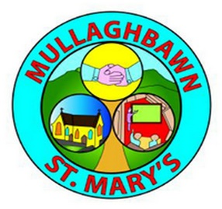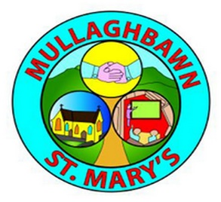**Mullaghbawn Skills Academy**

**What is the skills academy?**

The skills academy is a coaching initiative which aims to compliment the work of our clubs delivering a skills-based programme for our pupils. These sessions will be led by qualified coaches.

**Why are we doing this?**

There are a few aims of the skills academy, they include;

* Improving the overall skill level of our young players. This will be monitored through a skills assessment programme
* Increase the number of young people playing GAA in the school.
* Provide quality coaching/ interactions with pupils inspiring them to achieve with their club.

**How will the academy work?**

* Club coaches/ players will attend the school everyday to conduct coaching sessions which will be skills based as well as progressive from week to week.
* The sessions will be after school and during school hours.
* To fund the academy, there will be a fee of £3 per hour for afterschool. (This will fund the coaches for their time as well as a pair of socks for those pupils that take part in the academy.)
* The skills academy will offer two afterschool slots per week for each age group in the school. Coaching during school hours will be in addition to this and will be free of charge.
* Running along side the academy will be a Winter sports programme hosted at the club in the evenings beginning in October and running for 20 weeks. This will also be free of charge.

**Important information-**

Timetable 18/09/23- 20/10/23

|  |  |  |  |  |  |
| --- | --- | --- | --- | --- | --- |
|  | Monday | Tuesday | Wednesday | Thursday | Friday |
| 2pm | P4 (subsidised) | P2 | P3 | P2 | P3 |
| 3pm | P5 | P6/7 girls | P6/7 boys | P4 | P5 |

* Timetable will be reviewed and will be altered after midterm. The subsidised slot will also change to allow other year groups to avail of it.
* With regards to weather, children are asked to bring appropriate footwear and clothing to allow for rain. In cases of extreme weather, the sessions maybe be called off. This will be communicated through a WhatsApp broadcast message. The amount paid will also be refunded or carried over to the next block of coaching.
* Sessions will take place on the school pitch, yards and Conway Park basketball court.

**Pricing-**

Pricing is based off of the 6-week period in the build up to midterm 18/09/23- 20/10/23

**P2/P3/P5**

* £3 Per child/ Per hour or
* 10 hours for £25 over 5-week period

**P4/P6/P7**

* £3 Per Child/ Per hour or
* 5 Hours for £12.50 over 5-week period

Exact payment should be enclosed in an envelope with name of child and their year group.

**Permission slip**

I give permission for my child ______________________ to take part in the Mullaghbawn skills academy.

In case of emergency or cancelation I can be contacted on this number __________________________ I also consent to being added to a WhatsApp broadcast group to be alerted of any cancelation.

Signed Parent or Guardian _______________________________

Any queries, please contact Club coaching officer Mark through WhatsApp 07729453930