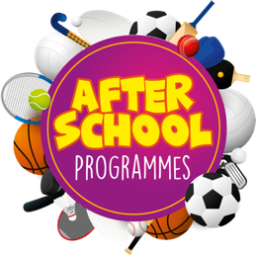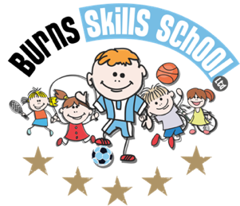St Mary’s

Primary School

Mullaghbawn

Hip Hop

**P2 - P3 + P4 - P7**

Gymnastics

**P2 - P3 + P4 - P7**

Lego

**P2 - P3 + P4 - P7**

Wed 11th Sept

Wed 18th Sept

Wed 25th Sept

Wed 2nd Oct

Wed 9th Oct

Wed 16th Oct

Wed 6th Nov

Wed 13th Nov

Wed 20th Nov

Wed 27th Nov

Wed 4th Dec

Wed 11th Dec

Fri 13th Sept

Fri 20th Sept

Fri 27th Sept

Fri 4th Oct

Fri 11th Oct

Fri 18th Oct

Fri 8th Nov

Fri 15th Nov

Fri 22nd Nov

Fri 29th Nov

Fri 6th Dec

Fri 13th Dec

Fri 13th Sept

Fri 20th Sept

Fri 27th Sept

Fri 4th Oct

Fri 11th Oct

Fri 18th Oct

Fri 8th Nov

Fri 15th Nov

Fri 22nd Nov

Fri 29th Nov

Fri 6th Dec

Fri 13th Dec

**Primary 2 – Primary 3** (2.00pm-3.00pm each week) **Primary 4 – Primary 7** (3.00pm-4.00pm each week)

To secure a place for your child you mustenrol online via **www.burnsskillsschool.co.uk** This is very easy and straightforward. Click ‘secure your place’ at the top of the website. Then scroll down to find your child’s school and the correct activity to enrol. Deadline for payment is **Friday 6th September*.*** This is a great opportunity for your child and certainly one not to be missed. When in attendance we would advise that all children wear appropriate clothing with a pair of trainers suitable for indoor and outdoor.

**Numbers will be limited for each session!**

**Note: The total cost of the term will be split into two payments. Once signed up you must pay both installments. The first payment of £30.00 is due on registration and the second payment of £30.00 will be due in October. Please note this is not two blocks of 6 weeks. This is one block of 12 weeks split into two payments to help make it more affordable for parents with more than one child. All spaces are non refundable.**

**Payment options: *Online***

***Thanks***

***Aaron & Andrew***